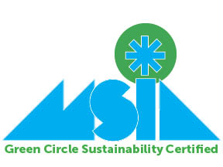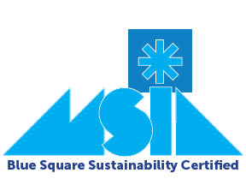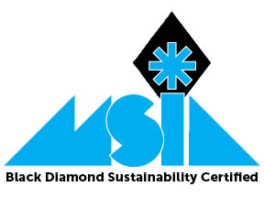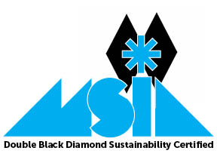
MSIA Sustainability Certification Program Application 2019/2020
Applications will be accepted until April 1, 2020
The document, in hard copy or email, must be sent to MSIA. Email to: info@goskimichigan.com Mail to: MSIA, 7164 Deer Lake Court, Clarkston, MI 48346..
MSIA created its Sustainability Certification Program to enable our members to take the lead in ski industry sustainability efforts. We chose to use the green circle, blue square and black diamond symbols that are already familiar to our industry, as they signify the “easiest,” “more difficult” and most difficult” paths down a slope or trail. MSIA’s Sustainability Certification Program is designed to be a map for its members to achieve sustainability success down the trail that is right for them. All MSIA members – Ski Areas, Ski Retailers, Ski Industry Manufacturers Reps and Associate members – can become Sustainability Certified because it is general enough for all businesses to be able to take part.
- Applications are accepted annually and must be completed by April 1 each year, so that we can announce results on Earth Day. The results will be for the prior winter season. As an example, applications received by April 1, 2020, will be valid to receive the certification for the 2019/20 winter. However, you don’t have to wait until April to submit your application. We’ll accept them anytime you’re ready. We just won’t make the announcements until April each year.
- An initiative can only be used once. As an example, if you recycle and provide recycle bins for customers and staff you can count this as “Recycling” under Managing Waste but you can’t double dip and also count this under Educate/Advocate/Lead as “Encouraging Employees and customers to embrace sustainability by making it easy for them to participate.”
There are four levels of certification and each can be achieved by performing, at minimum, the designated number of activities from each of the four categories below.
- Green Circle Certification: Perform at least TWO activities from each of the four categories below.
- Blue Square Certification: Perform at least THREE activities from each of the four categories below.
- Black Diamond Certification: Perform at least FOUR activities from each of the four categories below.
- Double Black Diamond Certification: Perform a minimum of ALL BUT ONE of the activities in each of the four categories below. For this certification you must include one “other” activity in each of the four categories.

The Four Categories:
- Managing Waste
- Energy Efficiency
- Environmental Protection
- Educate/Advocate/Lead

Company:
Address:
Name of person completing application:
Signature of person completing application:
Phone Number:
Email Address:
Date:
Category 1: Managing Waste

___ Implement a recycle program for at least two of the following:
  - Paper (office, newspaper, magazines, etc.)
  - Plastic
  - Printer cartridges
  - Cardboard
  - Glass
Description of your program:

___ Implement a composting program.
Description of your program:

___ Conduct a waste audit to see what your current consumption is and where you could reduce waste.
Description of your program:

___ Adopt business/office policies that are waste conscious, including adjusting printer settings to default to two-sided, offering emailed receipts instead of printed, filing documents electronically as opposed to paper files, no idle policy for employee and company vehicles, etc.
Description of your program:

___ Convert from using disposable products to reusable, recyclable (if you recycle) or compostable items.
Description of your program:

___ Work with local food pantry/charity for immediate use of food reaching end of life.
Description of your program:

___ Change purchases from single-use products to bulk. Examples: large containers of shampoo and conditioner in hotel bathrooms instead of single-use products; condiments in pump bottles instead of individual packets.
Description of your program:

___ Other program you have implemented for Waste Management.
Description of your program:

Category 2: Energy Efficiency

___ Contact your energy provider for an energy audit.
Description of your program:

___ Using alternative energy, renewable fuels or specialized energy-efficient technology in property management.
Description of your program:

___ Implement an energy-saving program that may include (but is not limited to) LED lighting, motion/occupancy sensors, programable thermostats, etc.
Description of your program:

___ Create closing process to ensure lights and select appliances are being turned off as opposed to sleep mode.
Description of your program:

___ Convert to High Efficiency equipment as they need replacing.
Description of your program:

___ Work with your energy provider to create a Demand Response – or similar program (could save money as well as energy.)
Description of your program:

___ Other program you have implemented for Energy Efficiency.
Description of your program:

Category 3: Environmental Protection

___Buy green, buy local to minimize food and product miles. Commit to a program to purchase products and services from local Michigan companies.
Description of your program:

___ Discontinue use of products that cause pollution, including polystyrene, K-cups, plastic straws, plastic bags, etc.
Description of your program:

___ Adopt the use of alternative cleaning products that are certified biodegradable and earth friendly.
Description of your program:

___ Create a program to properly dispose of hazardous materials (batteries, fluorescent light bulbs, oil, chemicals, installation of an oil/water separator etc.)
Description of your program:

___ Institute a water management program which may include any or all of the following: glasses of water only upon request at restaurants, installing efficient flush toilets/urinals/shower heads/faucets, drought-tolerant plantings, annual analysis and maintenance of septic system (if you have a septic system), replace water pipes (for irrigation, snowmaking, hotel use etc.) that leak or are too small for energy efficiency, etc.
Description of your program:

___ Install electric charging station(s).
Description of your program:

___ Other program you have implemented for Environmental Protection.
Description of your program:

Category 4: Educate/Advocate/Lead
___ Integrate your environmental/sustainability program and goals into your brand message.
Description of your program:

___ Promote environmental issues by creating an employee sustainability committee, calendar of local environmental happenings available to employees/public or providing space for green tips or ideas in an employee/customer newsletter, blog or email.
Description of your program:

___ Encourage employee environmental volunteer days (to give back to the community) and provide some type of acknowledgment for their service.
Description of your program:

___ Educate customers with signage about straw use, towels (in lodging facilities) glasses of water when requested (in restaurants), and/or other recycling/composting/reusing programs at your facility.
Description of your program:

___ Contact your local legislators about issues that deal with sustainability.
Description of your program:

___ Join and/or support environmental/sustainability organizations that align with your sustainability goals.
Description of your program:

___ Encourage employees and customers to embrace sustainability by making it easy for them to participate – examples: install bike racks, a bike commuter shower, water bottle refill station, etc.
Description of your program:

___ Create a sustainability plan road map. Outline how you plan to achieve specific goals by specific dates.
Description of your program:

___ Other program you have implemented to Educate/Advocate/Lead.
Description of your program:

Once finished, return completed form to: info@goskimichigan.com
Or mail to:
MSIA
7164 Deer Lake Court
Clarkston, MI 48346

